Favorite Fictional Character

Entergalactic

Character: Jabari

Age: Young Adult

Gender: Male

Family: Sister Ellie

About: Jabari is a comic book artist, recently moved to Manhattan, battling the ups and downs of young adult life. His consciousness and problems are portrayed by his signature comic character Mr. Rager. He has a huge interest in modern pop culture, with his well curated outfits, and his pop culture inspired apartment loft.

1. High on life: Jabari is the classic stoner type yet seems to access a lot of his art inspo through his time inebriated. He likes to hang out with his friends, go to parties, but also spend time one on one time with people he cares about. He could be described as an ambivert in many ways.
2. Mr. Rager Creator: Jabari is the original creator and artist of Mr. Rager. A black silhouette character in a black suit, sunglasses, a large afro and a booming personality. He portrays his art as graffiti on walls, billboards, really anywhere he deems suitable for such an influential piece of art.
3. The Gang: Jabari has two main homies, Jimmy, who doubles as his weed dealer, and Ky, who is slightly confusing but overall, super chill homie as well. Together they get up to no good, go to parties, converse and tell crazy stories from their past, and more than anything, smoke A LOT of weed. Other friends include Downtown Pat, a homeless bmx biker with a ton of emotion and a lot of problems.

Fave quotes:

* Jabari: We only get so many chances to make the right choice
* Downtown Pat: Love is a motherfucker, boys. It'll find us all. It'll hurt us all. But goddamn it, it's the only thing that'll save us all. If you got it, hold on to it.

Images





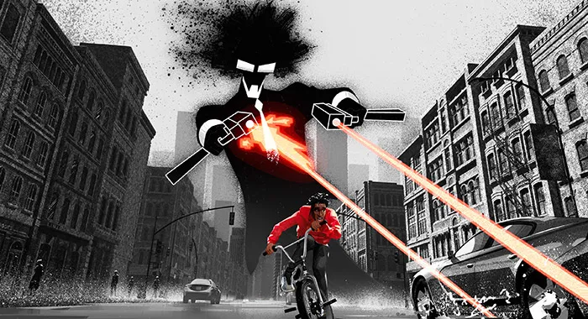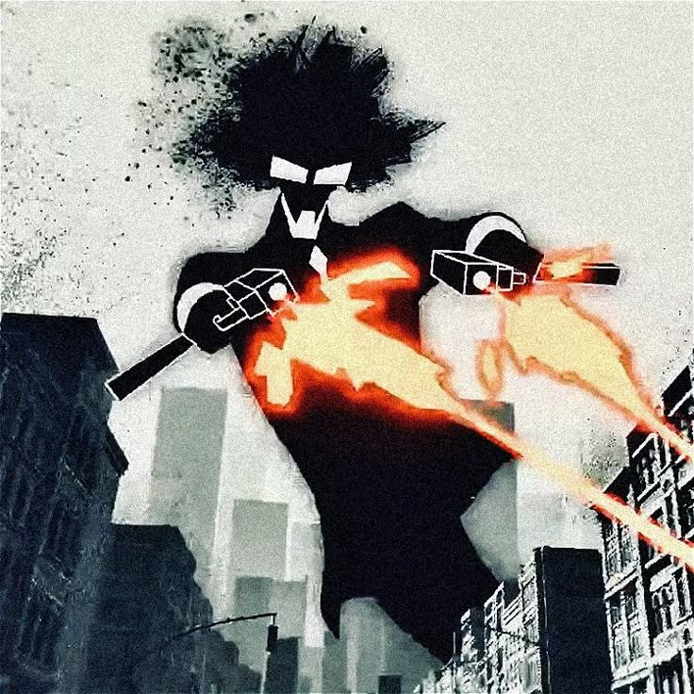

<https://editorial.rottentomatoes.com/wp-content/uploads/2022/10/entergalactic-2-700x380-1.jpg>

<https://encrypted-tbn0.gstatic.com/images?q=tbn:ANd9GcQ7htfiZZWRthg0TK5v9QoL0D5hZfx0yBNWq6vP4idJb35vsbyswCWr6itl8sRje5Yg9Do&usqp=CAU>

<https://m.media-amazon.com/images/M/MV5BYjU2NWM0OGUtNzMwMC00ZDUyLTkxNDctOGFmZjI1ZTZhZDkyXkEyXkFqcGc@._V1_QL75_UX389_.jpg>

<https://www.hollywoodreporter.com/wp-content/uploads/2022/11/Print-Issue-34A-rep_vision-Kudi-Entergalactic-Publicity-H-2022.jpg?w=200&h=200&crop=1>

<https://platform.theverge.com/wp-content/uploads/sites/2/chorus/uploads/chorus_asset/file/24056554/JABARI_FL_B_6.8.22.jpg?quality=90&strip=all&crop=21.875%2C0%2C56.25%2C100&w=2400>

<https://cdn.mos.cms.futurecdn.net/dnfGbDr4NZfb8f564X8BeF-1200-80.jpg>

https://sala7design.com.br/wp-content/uploads/2023/03/Entergalatic-Netflix-14.png